Unit 2 – Lesson 1. Introduction to Android Fragments
Aim:
What is Android Fragment and how do we use Fragments in Android apps?

Objectives: After the lesson, students will be able to:
- Obtain understanding on Fragments
- Build a simple Android App using Fragments

CLASS PROCEDURE:

Do Now:
Go to public drive:\Qiu1\2017 - 18 App Development, if you haven’t copied over the androidpf2_examples, please copy the zip file to your USB flash drive and unzip it.

Open Android Studio, and import the app named FlagQuiz. Run and explore the app. There are many activities and functions in this app. How do we reuse some of the functions?

Class Discussion / Presentation:

- What is a fragment?

A fragment encapsulates functionality so that it is easier to reuse within activities and layouts. A fragment runs in the context of an activity, but has its own life cycle and typically its own user interface.

- What is the primary reason to use Fragment in Android app development?
- Fragments provide a convenient mechanism for creating reusable modules of application functionality consisting of both sections of a user interface and the corresponding behavior. Once created, fragments can be embedded within activities.

- What are some of the examples of using fragments in Android?
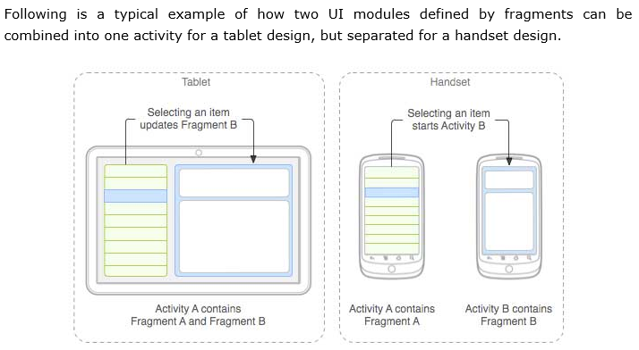

- What is the life cycle of Android Fragment?

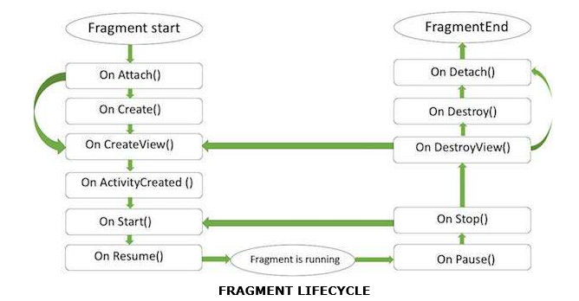

Pair – sharing Activity #1 / Lab - Time - picker:

Open Android Studio, create a new project with a blank activity and name the project “TimePicker”.
In this app, the user can pick time on a clock time picker as shown in the GUI below.

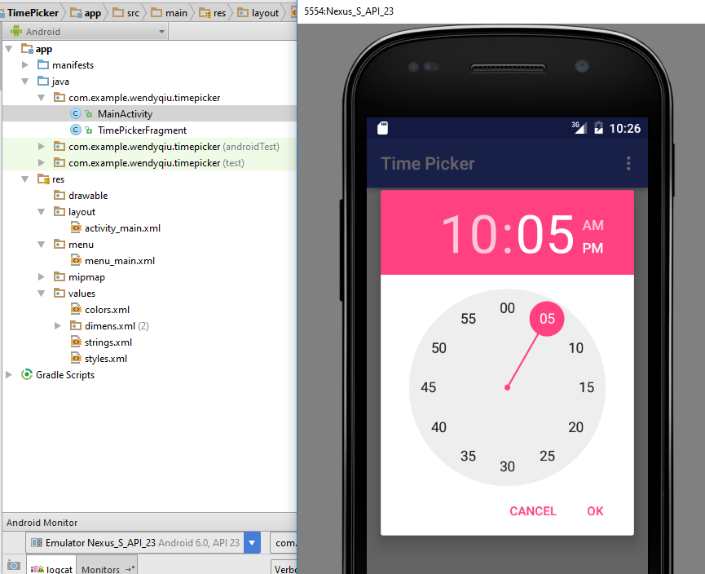

Work with your partner and complete the app. Test it on the emulator. Discuss with your partner and answer the following questions:

- How is fragment being used in this app?

- How do we add menu to the app?

- How does the app pass the Text View input to the clock Time Picker?

- How does the app pass the time input from the clock Time Picker to simple Text View?

activity_main.xml

<RelativeLayout xmlns:android="http://schemas.android.com/apk/res/android"
xmlns:tools="http://schemas.android.com/tools"
android:layout_width="match_parent"
android:layout_height="match_parent"
android:paddingBottom="@dimen/activity_vertical_margin"
android:paddingLeft="@dimen/activity_horizontal_margin"
android:paddingRight="@dimen/activity_horizontal_margin"
android:paddingTop="@dimen/activity_vertical_margin"
tools:context=".MainActivity" >

<TextView
android:id="@+id/textView1"
android:layout_width="wrap_content"
android:layout_height="wrap_content"
android:layout_alignParentTop="true"
android:layout_centerHorizontal="true"
android:text="@string/init_text"
android:textAppearance="?android:attr/textAppearanceMedium" />

<Button
android:id="@+id/btn1"
android:layout_width="wrap_content"
android:layout_height="wrap_content"
android:text="@string/pick_time"
android:onClick="showTimePickerDialog"
android:layout_marginTop="125dp"
android:layout_below="@+id/textView1"
android:layout_centerHorizontal="true" />

</RelativeLayout>

String.xml

<resources>
<string name="app_name">Time Picker</string>

<string name="action_settings">Settings</string>
<string name="init_text"> Time Picker Example</string>
<string name="pick_time">Pick Time</string>
</resources>

MainActivity.java

package …….

import android.os.Bundle;
import android.support.v4.app.DialogFragment;
import android.support.v7.app.AppCompatActivity;
import android.view.Menu;
import android.view.MenuItem;
import android.view.View;

public class MainActivity extends AppCompatActivity {

@Override
protected void onCreate(Bundle savedInstanceState) {
super.onCreate(savedInstanceState);
setContentView(R.layout.activity_main);
}

@Override
public boolean onCreateOptionsMenu(Menu menu) {
// Inflate the menu; this adds items to the action bar if it is present.
getMenuInflater().inflate(R.menu.menu_main, menu);
return true;
}

@Override
public boolean onOptionsItemSelected(MenuItem item) {
// Handle action bar item clicks here. The action bar will
// automatically handle clicks on the Home/Up button, so long
// as you specify a parent activity in AndroidManifest.xml.
int id = item.getItemId();

//noinspection SimplifiableIfStatement
if (id == R.id.action_settings) {
return true;
}

return super.onOptionsItemSelected(item);
}

public void showTimePickerDialog(View v) {
DialogFragment newFragment = new TimePickerFragment();
newFragment.show(getSupportFragmentManager(), "timePicker");
}

}

TimePickerFragment.java

import android.app.Dialog;
import android.app.TimePickerDialog;
import android.os.Bundle;
import android.support.v4.app.DialogFragment;
import android.text.format.DateFormat;
import android.widget.TextView;
import android.widget.TimePicker;

import java.util.Calendar;

public class TimePickerFragment extends DialogFragment
implements TimePickerDialog.OnTimeSetListener {

@Override
public Dialog onCreateDialog(Bundle savedInstanceState) {
// Use the current time as the default values for the picker
final Calendar c = Calendar.getInstance();
int hour = c.get(Calendar.HOUR_OF_DAY);
int minute = c.get(Calendar.MINUTE);

// Create a new instance of TimePickerDialog and return it
return new TimePickerDialog(getActivity(), this, hour, minute,
DateFormat.is24HourFormat(getActivity()));
}

public void onTimeSet(TimePicker view, int hourOfDay, int minute) {
// Do something with the time chosen by the user
TextView tv1=(TextView) getActivity().findViewById(R.id.textView1);
tv1.setText("Hour: "+view.getCurrentHour()+" Minute: "+view.getCurrentMinute());

}
}

menu_main.xml

<menu xmlns:android="http://schemas.android.com/apk/res/android"
xmlns:app="http://schemas.android.com/apk/res-auto"
xmlns:tools="http://schemas.android.com/tools" tools:context=".MainActivity">
<item android:id="@+id/action_settings" android:title="@string/action_settings"
android:orderInCategory="100" app:showAsAction="never" />
</menu>

